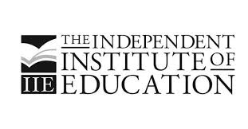
Shevon Lurie
Director of The Independent Institute of Education

SA PRIVATE HIGHER ED INSTITUTION INDUCTED INTO PRESTIGIOUS GOLDEN KEY SOCIETY
TOP 15% OF STUDENTS TO ENJOY INTERNATIONAL RECOGNITION & OPPORTUNITY

South Africa’s leading private higher education provider, The Independent Institute of Education (The IIE), has been inducted into the prestigious Golden Key International Honour Society – a recognition usually reserved for public universities.

The Golden Key International Honour Society is the world’s largest collegiate honour society for graduate and undergraduate students and has strong relationships with over 400 universities around the world, including in Australia, Canada, India, Malaysia, New Zealand, South Africa, The Bahamas and the United States. Membership into Golden Key is offered to undergraduate and graduate students recognised to be among the top 15% of their class.

The induction of The IIE as a chapter of the society means that their highest performing students will now be able to access the benefits of Golden Key membership, including bursaries, international professional development opportunities, and its global student networks.

Note to editor:
The Independent Institute of Education (The IIE) is a division of the JSE-listed ADvTECH Group, Africa’s largest private education provider. The IIE is the largest, most accredited registered private higher education institute in South Africa and is accredited by The British Accreditation Council (BAC), the independent quality assurance authority that accredits private institutions in the United Kingdom (UK).

