**Headmaster Cycles 800 km to Raise Funds for Dale College**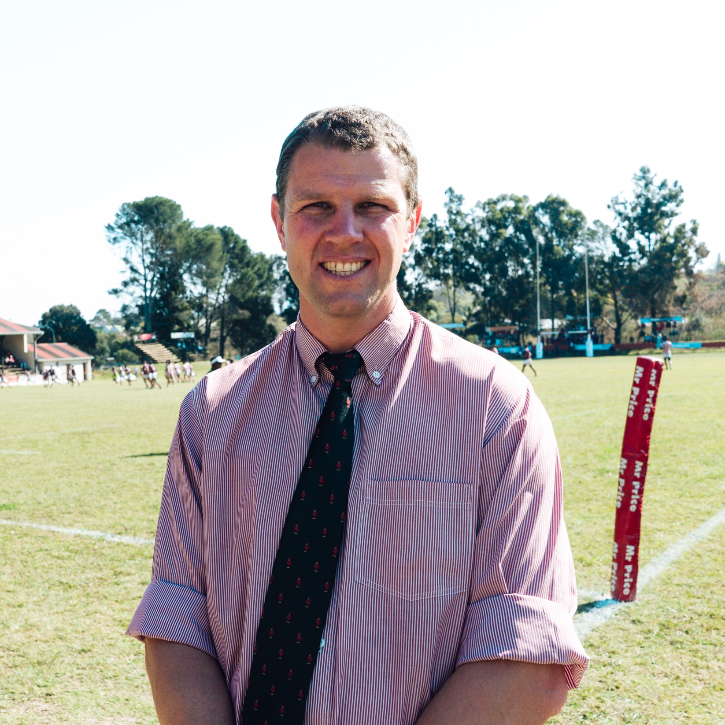

ByMr Sifiso Tembani - Principal's Assistant

My boss, Dr. Garth Shaw, currently Principal at Dale has undertaken to cycle from Dale College eQonce, to Northwood School eThekwini. He and his father Vincent, and Cayde Muldoon from Northwood School, are covering the scenic 800 km distance via the Wild Coast. The purpose of the journey is to raise seed capital for the newly established [Andy Andrews](https://www.damson.group/dm-andy.html) Financial Assistance Fund, which will be for the benefit of deserving learners from eQonce who cannot afford the school fees charged by Dale.



Dale College is a special place. I fondly remember attending the Primary School in the early noughties, and receiving a truly world-class foundation. Aside from the quality of teaching and coaching received, Dale instilled a certain mentality and self-esteem that is evident in every Dalian that you meet. Notwithstanding the above, I did not attend Dale College. I completed my matric at one of its peer schools in East London instead. I felt as though the school was in decline, with educational outcomes and learner discipline a particular point of concern. Regrettably, this would continue until Garth arrived in 2018, when the NSC pass rate had stooped to a frankly unacceptable 75%, with only 33% of learners achieving a Bachelor pass that year. Since then, however, a remarkable turnaround has occurred. 99% of learners passed matric in 2022, with 59% of them achieving Bachelor passes.

Dale is synonymous with unearthing rugby talent. As I write this piece, I note that Aphelele Fassi (Class of 2017) has been called up to the Springboks. He joins several other Old Dalians who have made it to the top levels of various sports. In the modern era alone, they include Makhaya Ntini, Monde Zondeki, Gcobani Bobo, Scarra Ntubeni, Tera Mtembu and many others. Indeed, Fassi is the current Player of the Year at the Sharks, while another Old Dalian, Kwanda Dimaza (2018) holds the same honour at the Pumas.

Jayden Hendrickse, the Springbok scrumhalf, is a notable case, however. Jayden attended Dale Junior before receiving a scholarship with a school in Durban. Dale did not have the resources to make him a counter-offer, and he therefore made the decision to leave his family behind and head to KZN. The reality is that while we have talented young boys here, we simply cannot compete with well-resourced schools who can offer Jayden (and many other Dale Junior learners) a full scholarship or some form of financial assistance. This is an example of the challenges that Garth’s cycle from eQonce to Northwood aims to address.

The Challenge is to support Dale College by sponsoring the Headmaster’s journey at a rate of 50-cents per kilometre. All proceeds will act as seed capital for the Financial Assistance Fund. Larger contributions and partnerships are also sought, and school management is available to discuss further. I encourage the reader to view our facebook page (<https://www.facebook.com/DaleCollege/>) for regular updates and videos of their progress. There’s a certain charisma about the Dalian, and I have no doubt that it is this charisma and infectious positivity that inspires Garth to make this gruelling, nine-day journey.

Dale College is an iconic school in many ways. The recent turnaround in academic outcome fortifies the idea that such talent need not be limited to the sports field, but is based instead on strong, holistic foundations. It is important for the entire educational landscape that schools like Dale College continue to produce role models and achievers that inspire the young men of this country, and I do hope that you will partner with us in furtherance of this objective.

Per Ardua ad Astra