**OPEN LETTER TO MINISTER of SPORTS, ARTS & CULTURE – MR. GAYTON MCKENZIE**

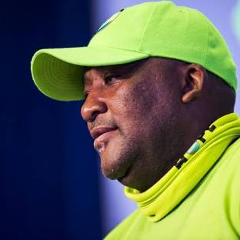

**OUR OLMPIC RESULTS**

Sir,

As we proudly congratulate our medal winners on their nation-building achievements and while the excitement of the spectacle of the Olympic Games subsides, it’s an opportune moment to **reflect on our sporting prowess as a country.**

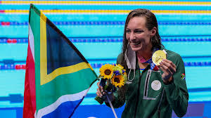

The table below makes for interesting comparisons, of the 205 participating nations - 89 won medals. SA ranked 42nd overall, in the top 50% of medal winners, and in the top 25% of participating countries.

We might deem that a satisfactory result. **We might even be proud of it.**

But, if we look at our performance as a ratio of medals per capita we **rank 71st out of the 89 countries**, not so good. By comparison, **Australia ranks 5th in medals won, 3rd per capita for countries with populations above 5 million, and 9th per capita overall.**

We don’t come anywhere near that.

**The fact is that ‘per capita’ we rank 71st out of 89 medal winning countries, in the bottom 20%**

Why?

**OLYMPICS - INTERESTING COMPARISONS: 89 0f 205 participating countries won medals**

|  |  |  |  |
| --- | --- | --- | --- |
|  | Medals won per country – Top 10 | Medals **per capita** won per country with pop **exceeding 5 million** – Top 10 | Medals **per capita** won per country – Top 10 |
| 1 | USA                            126 | New Zealand         20 | Grenada             2 |
| 2 | China                         91 | Hungary                   19 | Dominica           1 |
| 3 | Great Britian          65 | Australia.                 53 | Saint Lucia.       2 |
| 4 | France                       64 | Netherlands.          34 | New Zealand.   20 |
| 5 | Australia.                 53 | Denmark                  9 | Bahrain                4 |
| 6 | Japan                         45 | Norway                      8 | Jamaica               6 |
| 7 | Italy                            40 | Ireland                       7 | Cape Verde.       1 |
| 8 | Netherlands.          34 | Sweden                     11 | Hungary               19 |
| 9 | Germany                  33 | Bulgaria                     7 | Australia.             53 |
| 10 | Korea                          32 | Great Britain.          65 | Georgia                 7 |

|  |  |  |  |
| --- | --- | --- | --- |
| 42 | | South Africa.          6 | 71 South Africa           6 |
| 71 | India                            6 | | 89 India (last).             6 |
|  |  |  |  |

**Australia’s success**

My understanding is that back in the 1950’s Australia had a poor showing in the Olympics. In response their Government embarked on an aggressive programme of developing sport in schools, setting up sporting academy’s, identifying talent, improving coaching expertise, identifying those sporting disciplines in which they wished to excel, establishing high performance training facilities and **putting aside a decent budget** to enable the above.

**School Sport in SA**

I did some research on sport in our schools, examining the availability of 8 popular sporting disciplines in our 22 587 public schools. (only data on sporting disciplines I could find).

**NUMBER of SCHOOLS per PROVINCE offering Athletics, Tennis, Hockey, Netball, Swimming, Soccer, Cricket, and Rugby**

|  |  |  |  |  |  |  |  |  |  |  |
| --- | --- | --- | --- | --- | --- | --- | --- | --- | --- | --- |
| **Province** | **School**  **Sites** | **Athletics** | **Tennis** | **Hockey** | **Netball** | **Swimming pool** | **Soccer** | **Cricket** | **Rugby** | **NO facilities** |
| Eastern Cape | 5046 | 151 | 171 | 80 | 1472 | 72 | 1186 | 173 | 466 | **3167** |
| Free State | 945 | 62 | 146 | 47 | 547 | 16 | 442 | 105 | 34 | **257** |
| Gauteng | 2066 | 429 | 435 | 244 | 1288 | 168 | 1081 | 458 | 236 | **506** |
| KZN | 5797 | 207 | 158 | 129 | 1976 | 185 | 1603 | 271 | 121 | **3133** |
| Limpopo | 3649 | 81 | 103 | 36 | 2160 | 43 | 1585 | 67 | 37 | **1215** |
| Mpumalanga | 1649 | 79 | 121 | 56 | 747 | 22 | 694 | 69 | 279 | **579** |
| North West | 1448 | 130 | 128 | 51 | 692 | 32 | 811 | 96 | 83 | **290** |
| Northern Cape | 545 | 49 | 102 | 27 | 279 | 33 | 163 | 53 | 87 | **186** |
| Western Cape | 1472 | 87 | 233 | 113 | 857 | 23 | 744 | 157 | 105 | **387** |
| **9 provinces** | **22587** | **1273 (5.6%)** | **1589**  **(7%)** | **784**  **(3.4%)** | **10029**  **(44%)** | **580**  **(2.5%)** | **8301**  **(36.7%)** | **1444**  **(6.3%)** | **1448**  **(6.4%)** | **9735**  **(43%)** |

Source: The Department of Basic Education (DBE) through its Education Facility Management System (2023), in SAIRR Annual Survey 2024.

Don’t these figures, at least for one reason, explain why our Olympic results on a per capita basis are so poor?

**9735 out of a total of 22587 public schools have no sporting facilities at all = 43%**, or put differently **only 57% of our public schools HAVE sporting facilities** (I have not incorporated the +/- 2500 Independent schools in this analysis, no data available)

As you have often quipped, “the Devil is in the detail” so I have put the percentages below each sporting discipline regarding the facilities available across all schools ie. 5.6% of schools have athletics facilities, 7% tennis facilities etc. Notwithstanding the fact that some schools may offer more than one discipline.

But, Minister Mckenzie, the same DBE report reveals our school-going population is **12 684 886 learners**, that means statistically **5 454 500 children in our schools have no access to sporting facilities at all!**

I don’t have data available on the establishment of sports academy’s, talent hunting, coaching, high performance centers, but I’d imagine the picture is not much different.

I know you won’t do this, your track record speaks for itself, nevertheless, there are those out there who will quickly **blame our Apartheid legacy for these woeful numbers**. But as you yourself have said ‘we have had 30 years of a new dispensation – there is no room for continued blame.’

Australia turned their numbers round in less that 30 years, and now they are the most successful sporting nation competing in the Olympics on just about any measure.

So, while we warmly welcome our Olympic Sports team back, I trust you intend your legacy, as Minister of Sports, Arts and Culture, to put an end to these woeful ‘stats’ and ensure that our peoples can embark on a new trajectory of sporting prowess, with proper, and adequate, government support.

My request Sir is to please start in our schools, not just in the interests of global medal success, but also in the interests of a decent, holistic education.

Yours in anticipation,

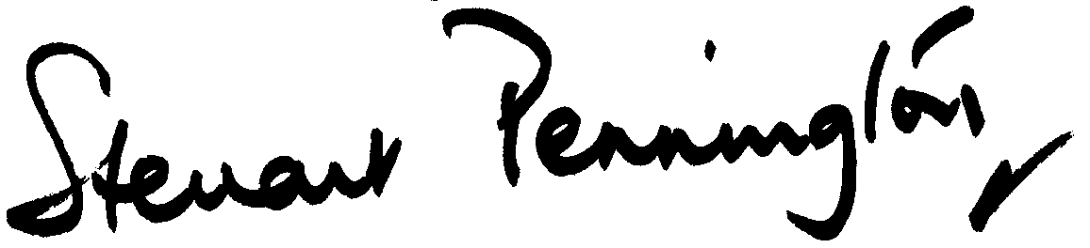

Steuart Pennington www.sagoodnews.co.za